1. Aboveground biomass data was from text on page

Biomass data was averaged from 525 and 429 = (525+429)/2 = 477.

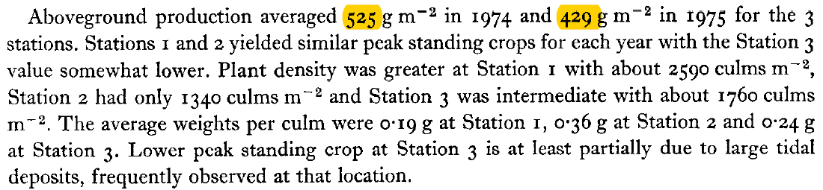

2. Belowground biomass data was from Table 2.

Meng found the max data 12300, however can’t find the min data 10000 from the table.

***[Response from Blanca]*** *Subtract the range (2.3) from the max, also in this table.*

The range of the belowground biomass data (2.3) was from Table 1.

Therefore, the min data= max – range = 12.3 -2.3 =10 (kg m-2)

